

Work Experience with Calderdale Music and The Piece Hall
Thank you for applying to take part in our exciting work experience opportunity with Calderdale Music and Roland UK at The Piece Hall on Sunday 25th August.
We welcome applications from students currently in Y11 – Y13 who either currently live and/or study in Calderdale and have an interest in music and the music industry.
We especially welcome applications from groups of students who are currently under represented in the sector at the moment. We are also aware of the factors contributing to this under representation and it is something that we are actively working on to address.
To secure your place, please complete the form below and return this via email to Samantha.Pearson@calderdalemusic.co.uk ASAP and no later than 10am on Saturday 17th August. Successful candidates will then be informed by email on Monday 19th August.

We are waiting for confirmation of timings for the day.
Please note, if students are invited to stay for the evening performance they will not be supervised by Calderdale Music staff after the end of the work experience session in the afternoon.

Students are expected to dress appropriately for work in this sector, we suggest comfortable clothes and footwear and consider potential weather implications as this is an outdoor venue.

We appreciate this is a last minute opportunity but as is so often the case in the real world music industry!

We look forward to seeing you there and working with you!

Calderdale Music
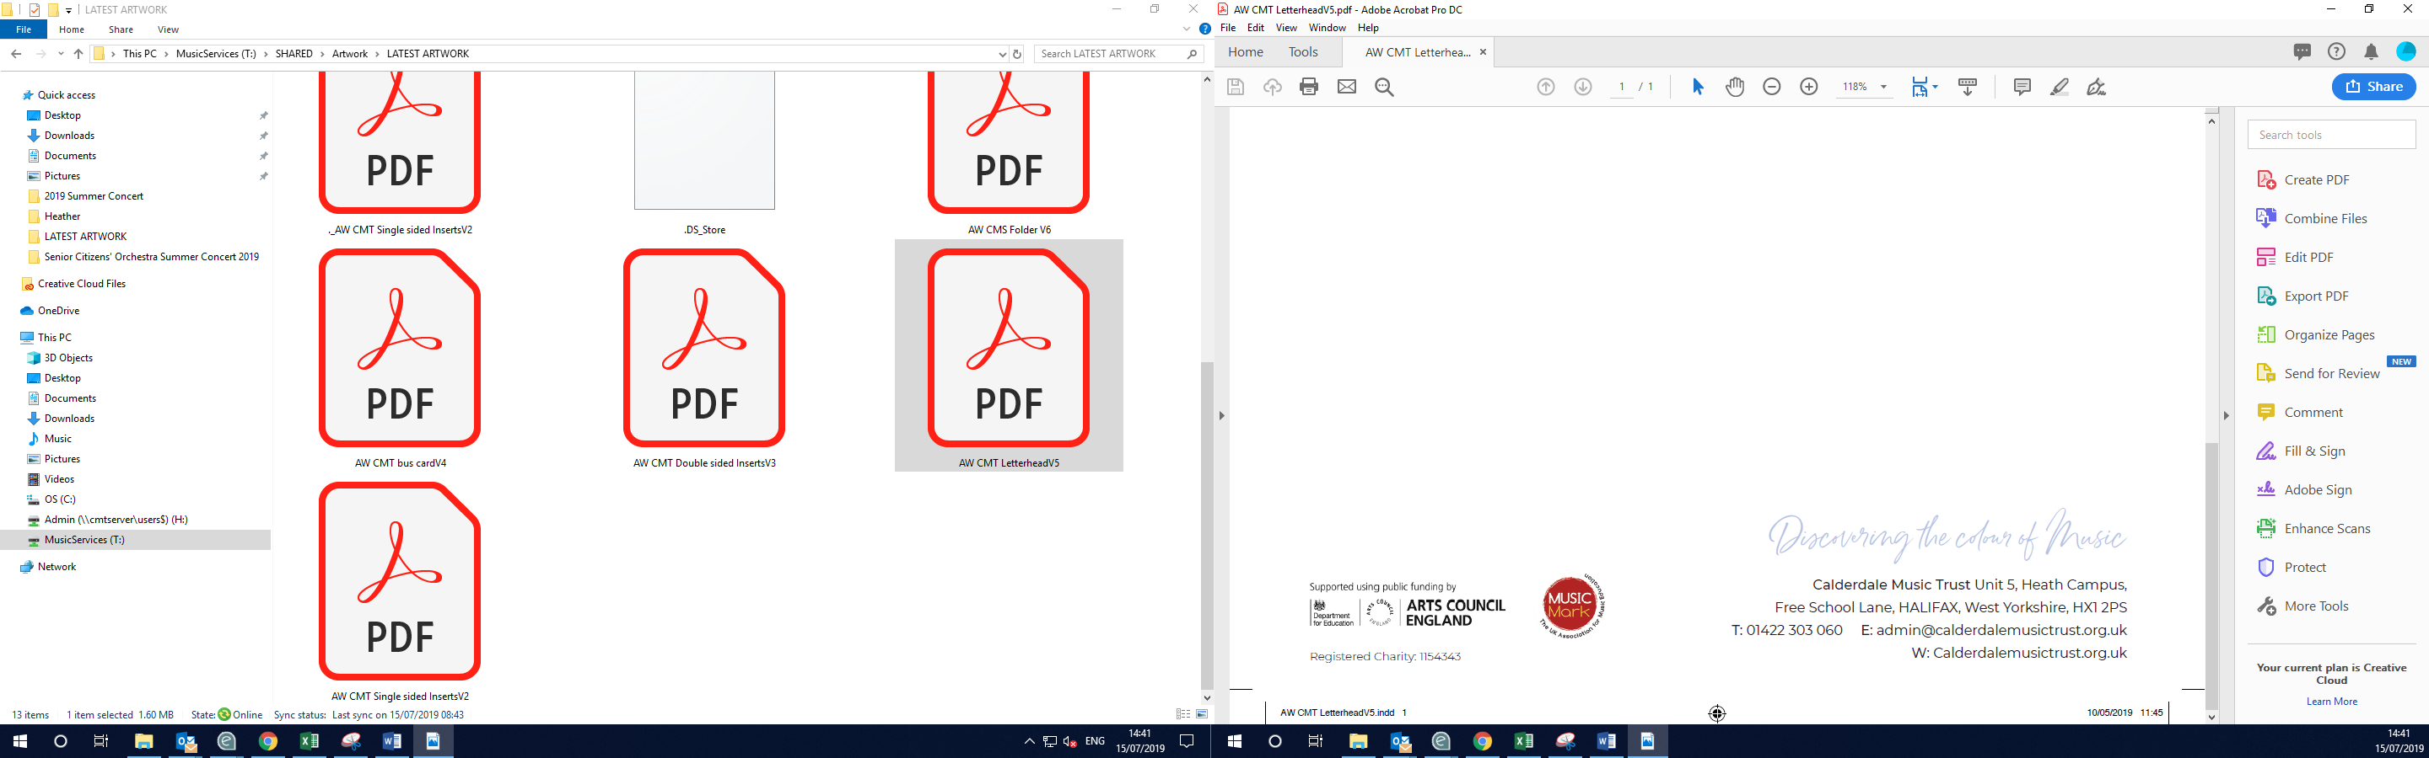

The Old Courthouse, Blackwall, Halifax, HX1 2DL
admin@calderdalemusic.co.uk
01422 401260
www.calderdalemusic.co.uk

PLEASE COMPLETE THE INFORMATION BELOW.
Pupil’s name: | Pupil’s Gender Identity: | Pupil’s Date of Birth: | Pupil’s School:
Any medical needs or dietary requirements that we should be aware of:

Please tell us a bit about your musical background – do you play an instrument, what style of music do you enjoy performing/listening to, do you take part in any bands or music groups?

What do you hope to gain from taking part in this experience?

Data Collection (Optional)
We are committed to gaining an accurate picture of the diversity
of our music students. Please state the pupil’s ethnicity.
What is the main language the pupil speaks at home?
Is the pupil a Looked After Child? | Yes / No
Does the pupil identify as disabled? | Yes / No
Does the pupil identify as LGBTQ+ ? | Yes / No

Parent/guardian name: | Parent/guardian email: |  |  | Parent/guardian contact number:
I confirm that I am 18 years or over |  | Yes/No | Signed:  Date:
I give media consent as outlined below and also have the permission of the pupil to sign on their behalf
I understand that Calderdale Music will not be responsible for pupils after the work experience session ends.
Media/Photography/Recorded Images Consent Form for Parents Of Pupils
Calderdale Music (CM) will promote its activity through recorded media taken from its tuition, events, performances and live streams. This material will contain images of children that have participated in CM events.
The interests and the welfare of children taking part in CM activities is paramount, therefore CM has put in place various safeguarding procedures. These safeguards will help to ensure that all necessary steps are taken to protect children and young people from the inappropriate use of their images in resources, media publications, on the internet and elsewhere.
CM will seek permission from parents/guardians of children to televise, record or photograph the tuition, event or performance(s).
If permission is gained, CM may use the recorded media for the following purposes:
- broadcasting any such recording or selling, hiring or otherwise making those sounds and images available in any audio, video or audio-visual form to the public without restriction
- making photographs available to the public without restriction
- using these sounds and images for publicity of the work of CM, including in collaboration with sponsors and funders anywhere in the world and retaining copies of the recordings and photographs in CM archives for use in future publicity for an unspecified time
Permission will be sought via a Recorded Media Consent Form.
Calderdale Music will:
- Never supply the full name (first name and family name) of the child or children along with the image/recording
- Only use images of children in suitable dress
- Only capture images/video on designated CM devices (e.g. Music Leader iPads), never on personal devices.
- Inform CM staff/volunteers that they will not take photos or make recordings at events for their own personal use which contain images of children.
Official photographers or film crews engaged by CM will be required to sign a contract to ensure the images are not misused and that no one else can gain access to the original copies. Depending on the role required of them by CM they may be required to have a DBS check. CM would never engage a photographer or film crew to work unsupervised away from the event location with children. CM will always inform groups when an official photographer or film crew has been engaged at an event.
Specific examples of previous usage of images and recordings by CM include the CM website, social media sites (YouTube, Facebook, Twitter and Instagram), press coverage – newspaper, radio and television, CM printed literature, Sponsor printed literature and online usage.
I hereby consent to Calderdale Music (CM), or anyone authorised by Calderdale Music:
- televising, recording or photographing the tuition, event or performance including my child.
Having captured these images, I confirm that CM is authorised to make arrangements for:
- broadcasting any such recording or selling, hiring or otherwise making those sounds and images available in any audio, video or audio-visual form to the public without restriction;
- making photographs available to the public without restriction;
- using these sounds and images for publicity of the work of CM anywhere in the world and retaining copies of the recordings and photographs in CM archives for use in future publicity for an unspecified time.
In signing this consent, I declare that I give my consent and also have the permission of the pupil to sign on their behalf in respect of the terms noted above.

