
Application – Self-Employed Music Tutor
Please complete the form and return this by email to Samantha.Key@calderdalemusic.co.uk
Personal Details
Title (select as appropriate) | Dr☐ Mr☐ Mrs ☐ Miss ☐ Ms ☐ Other (specify):
Surname (s)
First Names(s)
Previous Surname(s)
Address

Post Code
Email Address
Telephone (mobile)
Telephone (Home)
Date Of Birth |  | Nationality

Are you the holder of a current UK Driving Licence? | YES / NO
Type of Driving Licence?
Do you have access to a car? | YES / NO
Where did you see this position advertised?
Do you hold an Enhanced DBS certificate? | YES / NO
Do you have current subscription to the DBS update service? | YES / NO
Calderdale Music require all staff to have an enhanced DBS certificate on the update service. Calderdale Music can arrange a DBS check for you, for a cost of £70.

References
Please name two contacts below. One must be able to comment on your performance at work (usually your most recent employer)
Remember to ask your referees for permission before you give their name.
 | Reference One | Reference Two
Name
Email
Address

Post Code
Telephone
Occupation
Relationship To You
Present Employment
(or last job for applicants currently unemployed)
Job Title
Date From (MM/YY) |  | Date To (MM/YY) (if applicable)
Reason For Leaving/Looking For Other Employment |  | Notice Required (if applicable)
Name Of Employer
Address

Post Code
Current Salary |  | Grade
Briefly Describe Your Duties

Previous Employment
Job Title | Main Duties | Name and Address of Employer | From  (MM/YY) | To  (MM/YY) | Wage/Salary

Education and Qualifications
Name Of School/College/University Attended | Periods Of Study  Please indicate full/part time |  | Degrees Or Certificates Obtained | Dates Of Awards
Name Of School/College/University Attended | From (MM/YY) | To (MM/YY) | Details/Subjects/Grades | Dates Of Awards

Details Of Any Training Courses Attended In The Last 5 Years (Most Recent First)
Course/Training Title | Details | Date

Relevant Information
Please give any other information or relevant experience that demonstrates your ability undertake this role. You may use the person specification as a guide.

Teaching Responsibilities And Instruments
Please Indicate which instruments you can teach and to what grade.
Instrument | Grade | Any Other Notes
Please indicate which of the following teaching responsibilities you can undertake.
Classroom instrumental learning and music curriculum teaching require you to have previous experience.
 | Yes / No
One to one, paired and small group lessons
Small group is up to 6 pupils. Not applicable to drums/piano
Ensembles and bands including lunchtime or after school clubs
Workshops
One of sessions or short term projects, usually with up to 30 people.
Classroom Instrumental Learning
Music Curriculum Teaching
Please indicate which type of work you would be interested in:
 | Yes / No
Regular paid work
Takes place during term time. This teaching would be your own regular work.
Temporary cover work
Takes place during term time, to cover short term staff absence. This teaching would then be passed back to the regular teacher.
One-off on the day cover sessions
To cover a staff absence, similar to supply teaching. Usually just for one day or session. You would be contacted by phone in the morning on the day cover is needed to check your availability. This is likely to be for classroom instrumental learning or music curriculum teaching.
Your Availability
Please indicate when you are available for teaching during school term time.
Please note, school teaching can start any time from 8:15am and finish at 4:00pm. After school clubs may take place later than this.
Evening work is to 7:00pm. Saturday morning is 9:00am – 1:00pm.

 | AM | PM | Evening
Monday
Tuesday
Wednesday
Thursday
Friday |  |  | n/a
Saturday |  | n/a | n/a

Important Notice
Criminal Convictions
Please give details of all convictions/cautions. If none, please state “none.”

Date | Details of Offence |  | Sentence
As an applicant it is an offence to apply for a role that involves engaging in regulated activity relevant to children, schools and colleges if you are barred from engaging in such activity.
In line with Keeping Children Safe in Education 2021 guidelines, candidates will be asked to complete a self-declaration at shortlisting stage.
I declare that the information I have given on this form is complete and accurate and that I am not barred or disqualified from working with children and / or vulnerable adults nor subject to any sanctions or conditions on my employment imposed by a regulatory body or the Disclosure and Barring Service. I understand that to knowingly give false information, or to omit information, could result in the withdrawal of any offer of appointment, or my dismissal at any time in the future.
GDPR (General Data Protection Regulations) apply. We will treat all information relating to your application in confidence.

Signature
Print Name
Date

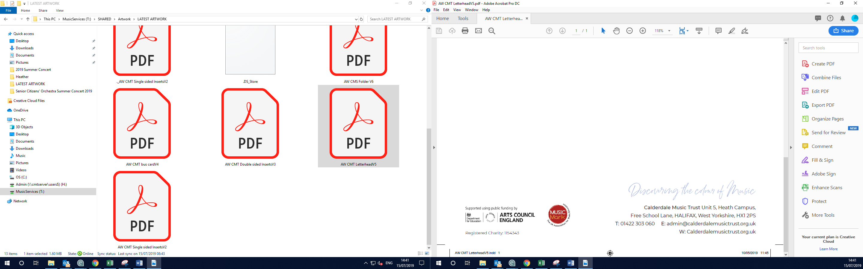

The Old Courthouse, Blackwall, Halifax, HX1 2DL
admin@calderdalemusic.co.uk
01422 401260
www.calderdalemusic.co.uk

