
Application – Music Leader
Please complete the form and return this by email to Samantha.Key@calderdalemusic.co.uk
Personal Details
Title (select as appropriate) | Dr☐ Mr☐ Mrs ☐ Miss ☐ Ms ☐ Other (specify):
Surname (s)
First Names(s)
Previous Surname(s)
Address

Post Code
Email Address
Telephone (mobile)
Telephone (Home)
Date Of Birth |  | Nationality

Are you the holder of a current UK Driving Licence? | YES / NO
Type of Driving Licence?
Do you have access to a car? | YES / NO
Where did you see this position advertised?

References
Please name two contacts below. One must be able to comment on your performance at work (usually your most recent employer)
Remember to ask your referees for permission before you give their name.
 | Reference One | Reference Two
Name
Email
Address

Post Code
Telephone
Occupation
Relationship To You
Present Employment
(or last job for applicants currently unemployed)
Job Title
Date From (MM/YY) |  | Date To (MM/YY) (if applicable)
Reason For Leaving/Looking For Other Employment |  | Notice Required (if applicable)
Name Of Employer
Address

Post Code
Current Salary |  | Grade
Briefly Describe Your Duties

Previous Employment
Job Title | Main Duties | Name and Address of Employer | From  (MM/YY) | To  (MM/YY) | Wage/Salary

Education and Qualifications
Name Of School/College/University Attended | Periods Of Study  Please indicate full/part time |  | Degrees Or Certificates Obtained | Dates Of Awards
Name Of School/College/University Attended | From (MM/YY) | To (MM/YY) | Details/Subjects/Grades | Dates Of Awards

Details Of Any Training Courses Attended In The Last 5 Years (Most Recent First)
Course/Training Title | Details | Date

Relevant Information
Please give any other information or relevant experience that demonstrates your ability undertake this role. You may use the person specification as a guide.

Teaching Responsibilities And Instruments
Please Indicate which instruments you can teach and to what grade.
Instrument | Grade | Any Other Notes

Important Notice
Criminal Convictions
Please give details of all convictions/cautions. If none, please state “none.”

Date | Details of Offence |  | Sentence
As an applicant it is an offence to apply for a role that involves engaging in regulated activity relevant to children, schools and colleges if you are barred from engaging in such activity.
In line with Keeping Children Safe in Education 2021 guidelines, candidates will be asked to complete a self-declaration at shortlisting stage.
I declare that the information I have given on this form is complete and accurate and that I am not barred or disqualified from working with children and / or vulnerable adults nor subject to any sanctions or conditions on my employment imposed by a regulatory body or the Disclosure and Barring Service. I understand that to knowingly give false information, or to omit information, could result in the withdrawal of any offer of appointment, or my dismissal at any time in the future.
GDPR (General Data Protection Regulations) apply. We will treat all information relating to your application in confidence.

Signature
Print Name
Date

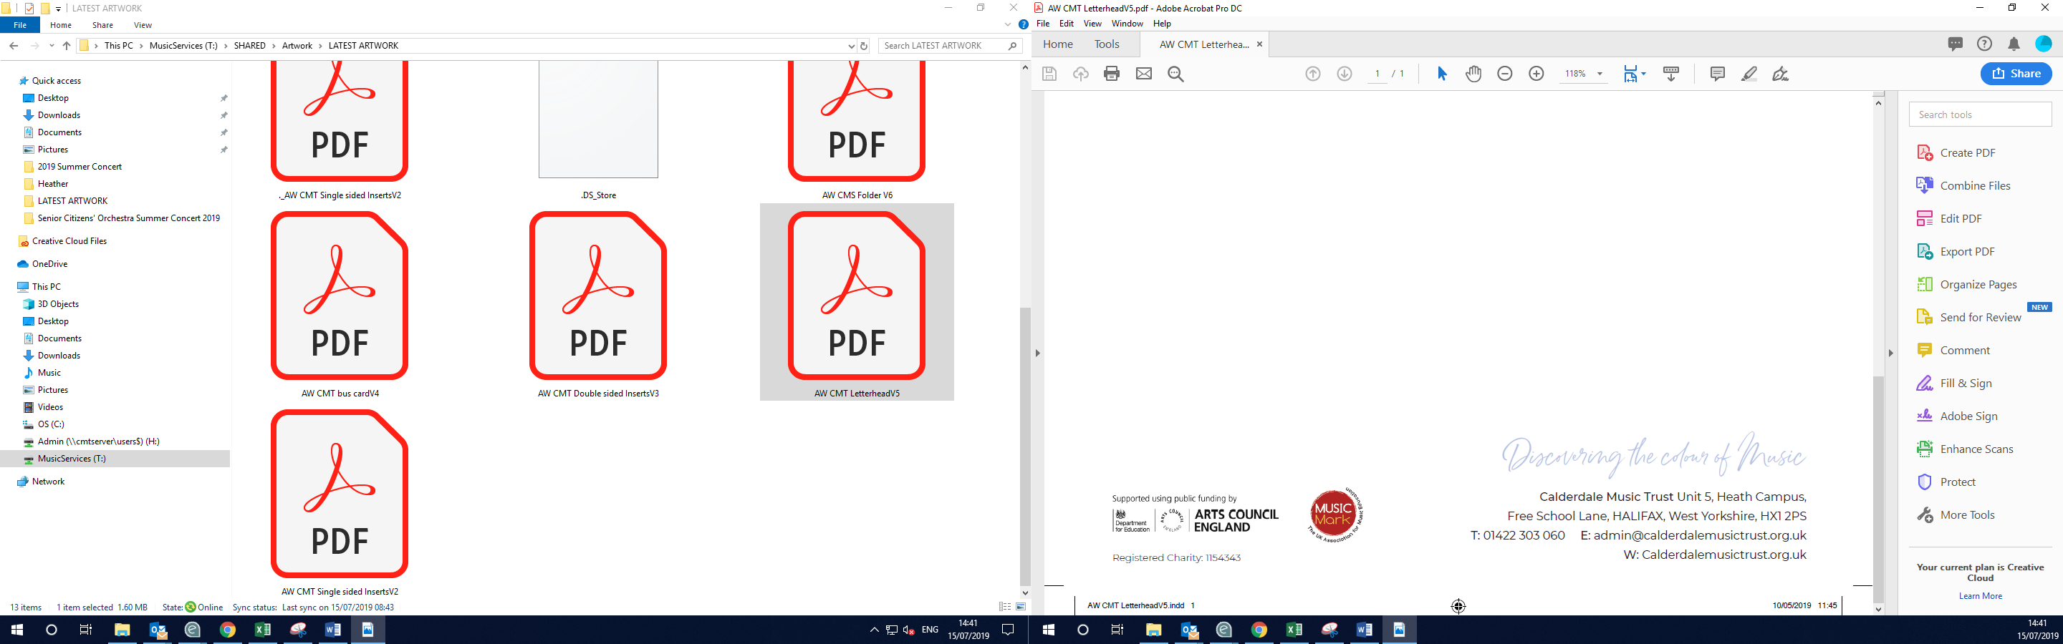

The Old Courthouse, Blackwall, Halifax, HX1 2DL
admin@calderdalemusic.co.uk
01422 401260
www.calderdalemusic.co.uk

